

**Care Connect – Design Document**

**By Dillon Reilly, Matthew Riddell, Erling Munguia, Abiel Lopez**

Table of Contents

Product Overview 1

Sample UI Design 1

Hardware Requirements 13

Hardware Connectivity Diagram 15

Data Gathered 16

Data Stored 17

Data Processed 18

Data Privacy and Security 18

# Product Overview

Care Connect is a user-friendly digital platform providing a network of communication that helps care givers and medical professionals who want to enhance dementia care and provide the highest quality care to people living with dementia by streamlining communication and data sharing unlike traditional fragmented methods. A bracelet worn by the patient can allow a newly assigned carer to obtain essential information via NFC in the application.

**Problem Statement**:

A way to support caregivers and medical professionals address the lack of a high-quality system for communication and information sharing, resulting in a disjointed and less efficient support network for people living with dementia (lack of care coordination).

To support caregivers and medical professionals communicate and share records more effectively resulting in better and more consistent care for the person living with dementia.

To alleviate the burden on care givers, providing a hub for information regarding individuals with dementia.

# Sample UI Design

**Login page:**

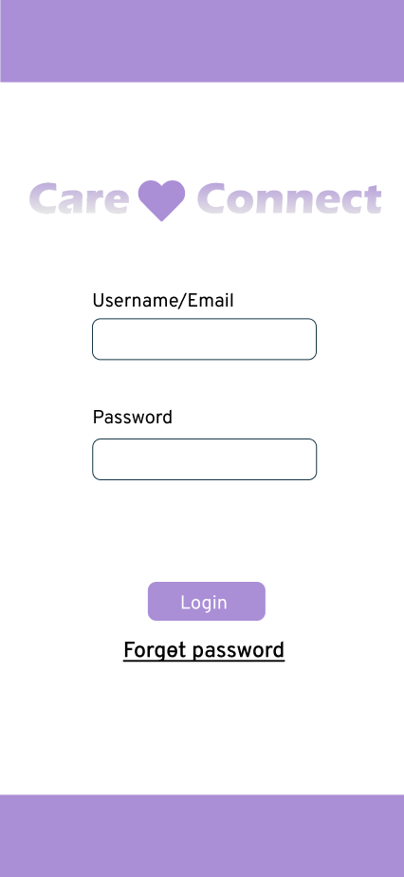

**Home Screen:**

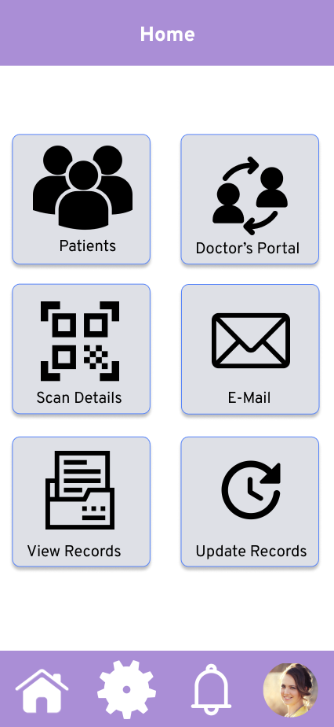

**User Profile (Career):**

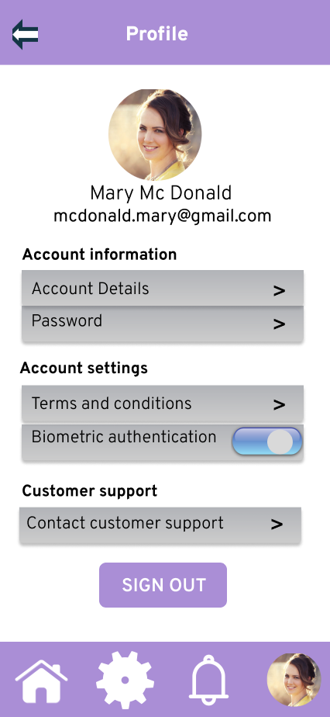

**User Profile (Doctor)**

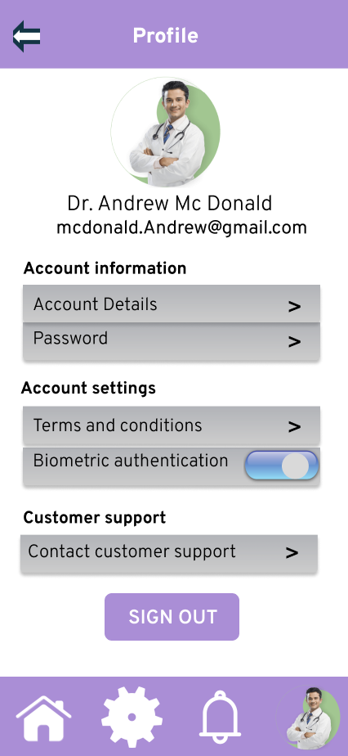

**Notifications:**

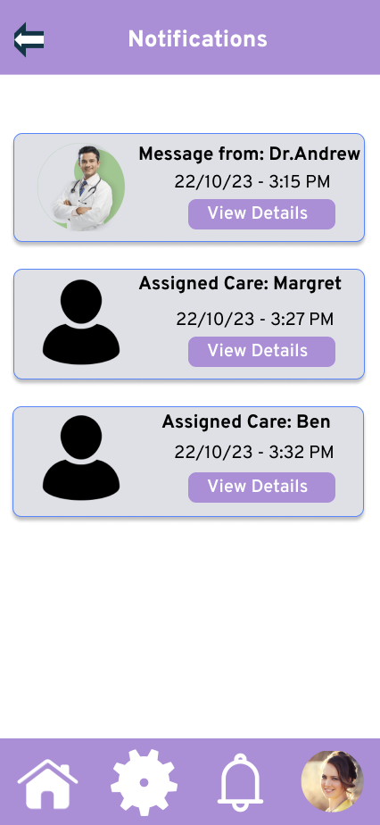

**Patients Screen:**

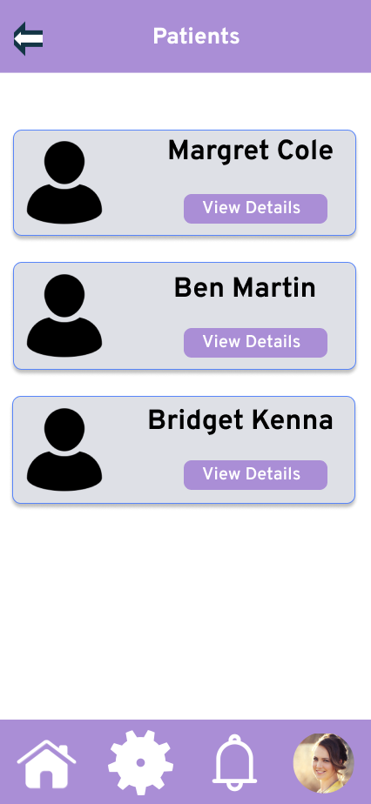

**Patient’s Profile:’**

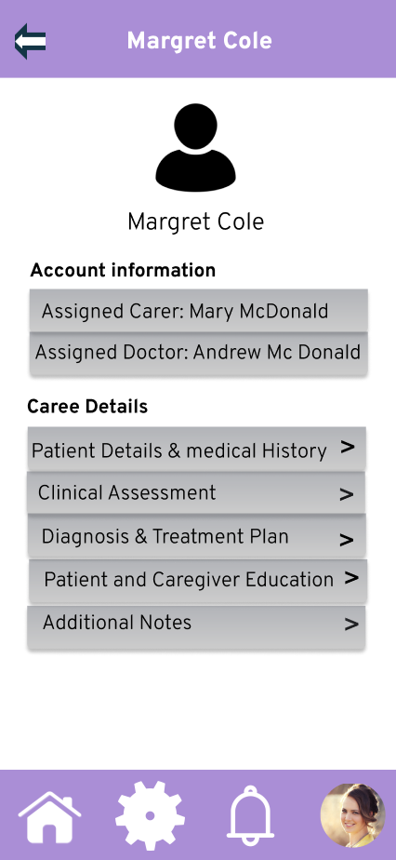

**Patient's Details:**

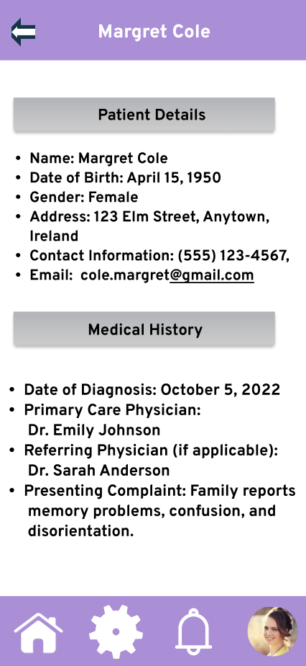

**Clinical Assessment:**

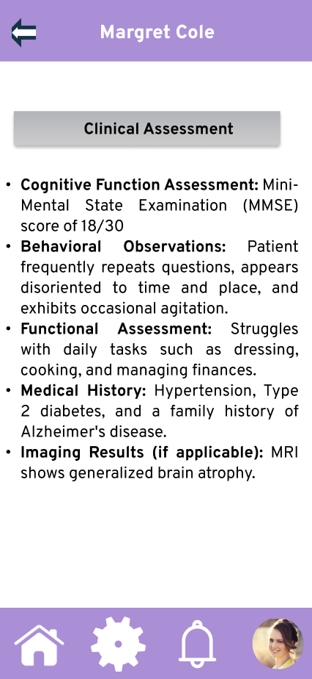

**Diagnosis:**

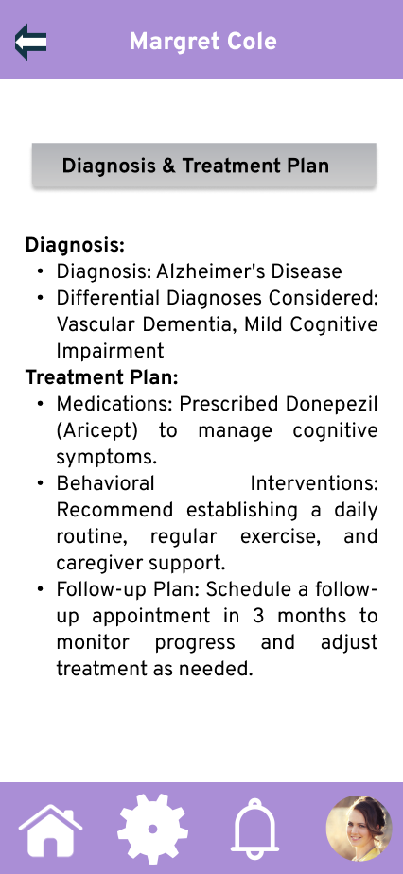

**Doctors Portal:**

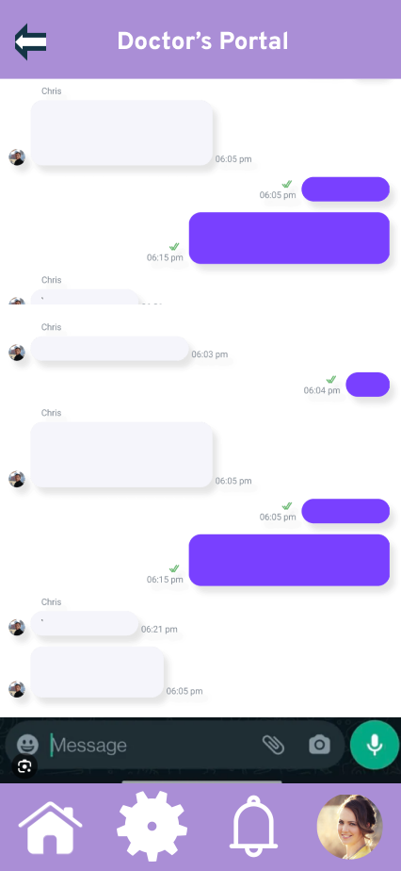

**Scan Patient Details:**

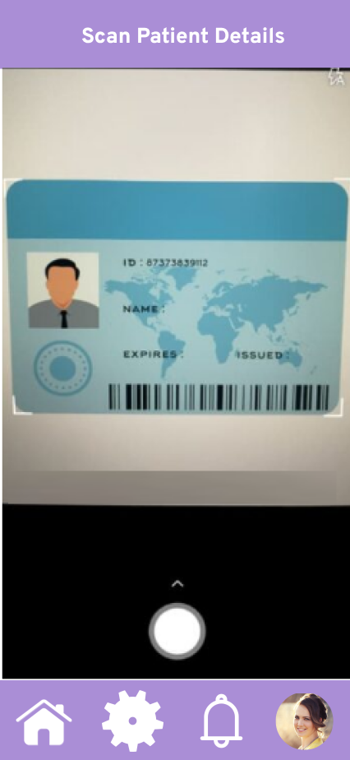

# Hardware Requirements

To build a wearable bracelet for people with dementia and have the device presented at the time of an appointment, you can consider incorporating various sensors and devices to improve its functionality and guarantee the well-being, safety, and comfort of the user. Below are some sensors and devices that can be used for its construction and development.

**GPS Sensor:** A GPS sensor can be integrated to track the person's location, which is especially useful for ensuring their safety and for locating them if needed.

* Sensor: GPS module (e.g., NEO-6M or UBlox NEO-7M)s.
* Python Library: Use the "gpsd-py3" library to interface with the GPS module.

**Heart Rate Monitor:** Monitoring the wearer's heart rate can provide valuable health information and help detect any irregularities.

* Sensor: Heart rate sensor module (e.g., MAX30100 or MAX30102)
* Python Library: Use a Python library such as "heartpy" to interface with the sensor.

**Button or Touchpad:** A simple input device that allows the wearer to trigger specific actions or alerts.

* Sensor: Momentary push-button or capacitive touch sensor
* Python Library: Simple GPIO control for buttons or touchpad.

**Wi-Fi or Cellular Connectivity:** These options can be used for real-time data transmission, location tracking, and communication with caregivers or a central monitoring system.

**SOS/Emergency Button:** A dedicated button for the wearer to call for help or alert caregivers in case of an emergency.

**Memory and Storage:** To store medical information, emergency contacts, and historical data.

* Sensor: EEPROM, flash memory, or Raspberry Pi's built-in storage.
* Python Library: Use Python's file I/O capabilities for storing data.

**NFC or RFID Chip:** This chip is used for storing the person's ID and relevant medical information for quick access by caregivers or medical professionals.

* Sensor: NFC or RFID module (e.g., PN532 or RC522).
* Python Library: Libraries such as "nfcpy" for NFC or "MFRC522" for RFID.

**Battery:** A reliable power source, which can be rechargeable or replaceable, to ensure continuous operation.

**Another option, a card reader chip:**

To create a chip card that contains information and can be read by another device and presented by an application for this purpose, you can use RFID (radio frequency identification) or NFC (near field communication) technology. These technologies are commonly used for this purpose and are supported by Raspberry Pi. It can be used as follows:

supported by Raspberry Pi. It can be used as follows:

**RFID or NFC card chip:**

**Sensor type:** RFID (radio frequency identification) or NFC (near field communication) chips.

**Use:** These chips store information and can be read by RFID/NFC readers or scanners. They are commonly used for access control, identification, and data transfer.

**Programming:** you can use Python libraries to develop interaction with RFID/NFC readers connected to a Raspberry Pi. Data read from the card chip can be transferred to a laptop for presentation.

Components:

**RFID/NFC card or tag:** Contains the desired information.

**RFID/NFC Reader:** Device that reads information from the card.

**Raspberry Pi:** To connect the RFID/NFC reader and run Python code to handle the data.

**Laptop:** To receive and display data from the Raspberry Pi through the application.

Python Libraries:

**For RFID:** You can use libraries like "MFRC522" or "RFID-RC522" for Raspberry Pi.

**For NFC:** Libraries like "nfcpy" can be used to interact with NFC readers.

The use of RFID or NFC technology is an effective way to create a card or chip that can store and transfer the information of people with dementia who will be the direct users of this device.

# Hardware Connectivity Diagram

**Option for the card:**

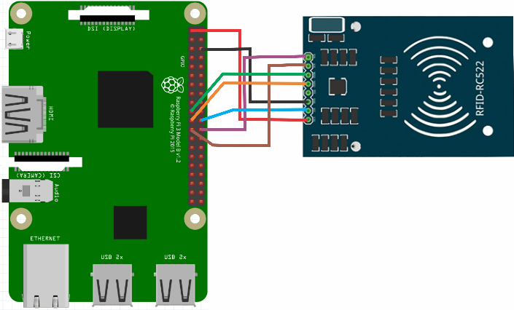

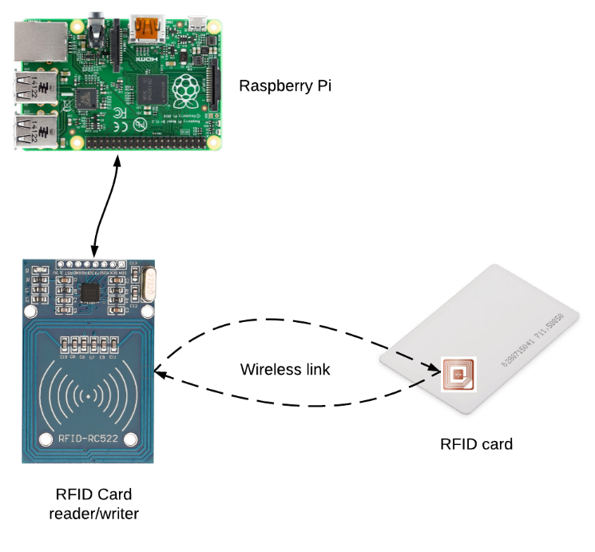

**Option for the bracelet:**

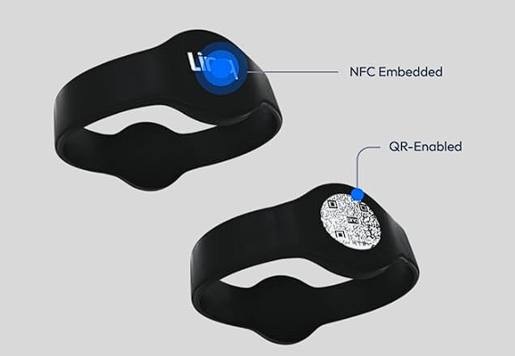 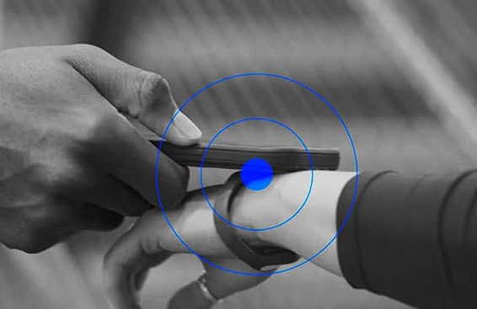

**Hardware Powered**

The power source of a bracelet, such as a wearable device or smart bracelet, depends on its design, functionality, and comfort for the user. Below are the following methods that can be used as a power source for the bracelet.

**Rechargeable battery:**

Users can recharge these batteries using a USB cable. Rechargeable batteries are convenient for daily use.

**Replaceable batteries:**

Some simpler bracelets may use replaceable button-type batteries like watch batteries. When the battery runs out, users can open the bracelet and replace the battery with a new one.

# Data Gathered

**Patient Information:**

* Patient’s personal details (name, date of birth, address).
* Medical history and various diagnosis.
* Current medication and treatment plans.

**Caregiver Information:**

* Caregiver’s personal details (name, date of birth, address, contact information).
* Relationship to the patient (family member or professional caregiver).
* Schedule and availability.

**Medical Professional (Doctor) Information:**

* Contact details.
* Specialization and expertise.

**Communication Data:**

* Messages exchanged between all involved parties.
* Notifications related to appointments and medication reminders.

**Notes and Records:**

* Care notes, progress reports, and incident reports.
* Any observed changes in the patient’s condition or behaviour, including rate of progress.

# Data Stored

As we are gathering a plethora of highly confidential and private information, security is of utmost importance when deciding on how we will store the data.

We will use Amazon RDS to provide cloud-based storage as it has functionality with MySQL and PostgreSQL.

**MySQL:**

* As a group, we have extensive experience with MySQL and MySQL databases.
* Well suited for structured data.
* Faster and more stable.

**PostgreSQL:**

* Allows us to store data as objects.
* Open-source and free.
* Boasts more features than MySQL.

# Data Processed

In our commitment to preserving the security, accessibility, and efficiency of data, we have devised a comprehensive strategy that encompasses the following key actions:

1. Data Backups: A regular backup schedule (Cron) will be implemented to create secure duplicates of patient data, ensuring its availability and integrity even in the face of unexpected disruptions.
2. Data Synchronization: For systems requiring data synchronization with remote servers, we will introduce scheduled tasks to maintain data currency and consistency across diverse platforms.
3. Data Archiving: We will establish processes for the periodic transfer of older data to separate storage, thereby enhancing database organization and responsiveness.
4. System Updates: Our ongoing efforts encompass the development of innovative data analysis techniques, geared toward extracting invaluable insights from the patient data. These insights serve as a crucial foundation for cultivating well-informed decision-making in healthcare management. We are fully committed to a routine update regimen that fortifies our technology against emerging threats and delivers an optimal service to our users.

To maintain the security and currency of our systems, we are fully committed to a routine update regimen that fortifies our technology against emerging threats and delivers an optimal service to our users.

# Data Privacy and Security

Ensuring the privacy and security of the data, especially when managing sensitive patient information is extremally important in our project. We are unwavering in our dedication to implement robust measures to protect data and adhere to relevant data privacy regulations.

Data Privacy:

As circumstances dictate, our project will diligently uphold pertinent data privacy regulations, exemplified by our commitment to conform with the stringent requirements of the well-known GDPR, which stands for the General Data protection Regulation. We will integrate feature that facilitates data anonymization as required, ensuring the protection of sensitive patient information during research and analysis.

Data Security:

Encryption: Our focus is on implementing robust end to end encryption protocols to safeguard data both during transmission and while at rest. We will employ HTTPS to secure communication between the client and the server, thereby ensuring the confidentiality and the integrity of the data.

Access Control: In our pursuit of data security, we will implement a robust framework known as role centric access control. This framework will simplify the control of user access to patient data by assigning specific roles and permissions to individuals, including caregivers and medical professionals thus streamlining the process. In our commitment to this method, we are resolute in the implementation of stringent access controls to safeguard sensitive information, allowing exclusive access solely to authorized personnel.

User Authentication: Stringent user authentication is our priority. To bolster the security of our System, we will require individuals to complete user authentication by submitting their designated username or email and passwords.

Data Auditing: to ensure transparency and accountability, we will implement detailed audit logs that record data access and modifications, including user identities, changes made and timestamps. These audit log will enable us to promptly identify and address potential security breaches.

Our focus on data privacy and security is geared toward establishing a secure environment for managing patient information. These measures are imperative for building trust and preserving the confidentiality and integrity of medical data throughout the project.